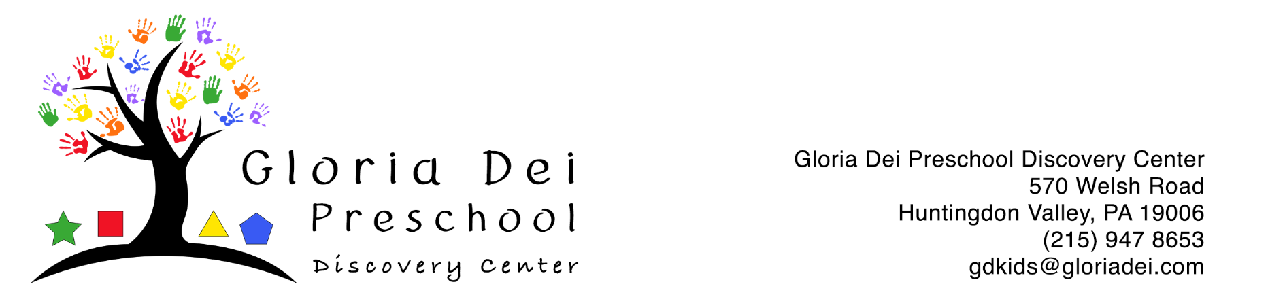

Shaken Baby Syndrome (Abusive Head Trauma) Prevention Policy
This policy is designed to prevent the possibility of abusive head trauma during care. Abusive head trauma (also referred to as Shaken Baby Syndrome) occurs in infants and young children, whose neck muscles are not well-developed and whose heads are larger relative to their bodies. As a result, they are especially susceptible to head trauma caused by any type of forceful or sudden shaking, with or without blunt impact. Damage can occur in as little as 5 seconds. Abusive head trauma can occur in children up to 5 years of age; however, infants less than one year are at greater risk of injury.
Shaken baby syndrome can lead to serious conditions including:
• Brain damage, problems with memory and attention, cerebral palsy;
• Blindness or hearing loss; • Intellectual, speech or learning disabilities; and
• Developmental delays. Signs and Symptoms The signs and symptoms of shaken baby syndrome or head trauma include:
• Seizures;
• Bruises;
• Lack of appetite, vomiting, or difficulty sucking or swallowing;
• Lack of smiling or vocalizing;
• Rigidity, inability to lift the head;
• Difficulty staying awake, altered consciousness;
• Difficulty breathing, blue color due to lack of oxygen;
• Unequal pupil size, inability to focus the eyes or track movement; or
• Irritability
Injury Prevention
Infant crying is normal behavior, which improves as a child ages. Caregivers should develop proactive strategies to manage stress levels and appropriate responses to a crying child. This includes being self aware and noticing when the caregiver may become frustrated or angry. Parents/guardians, caregivers and coworkers should discuss what calming strategies are successful with a particular child at home or in the center.
Emergency Response If a child presents any of the above symptoms or you suspect a child has suffered abusive head trauma:
• Call 911, call the parent/guardian and inform your director
• Report to the appropriate child protective services agency (or law enforcement, if applicable) within 24 hours or less as required by law.

Strategies for Prevention
A child is usually shaken out of frustration, often when the child is persistently crying or irritable. The following strategies may work some of the time; but sometimes nothing will comfort a crying child. A teacher should seek support from a coworker. If a child is inconsolable on a regular basis, the director should be notified and determine if the right supports are in place for the child and for staff.
Do:
• Hand the child to another caregiver.
• Place the child somewhere safe in the classroom (or home) and call the office (or a neighbor) for support; take deep breaths and count to 10.
• Check to see if the toddler’s diaper needs changing.
• Check for signs of illness and call the parent if you suspect the child is sick.
• Hold the baby close against your body and breathe calmly and slowly. • Gently rock the child using slow, rhythmic movements.
• Sing to the child or play soft, soothing music.
• Take the child for a walk indoors.
• Be patient: let the child cry it out if necessary.
Never:
• Shake a child.
• Drop a child.
• Throw a child into a chair, or car seat.
• Push a child into any object including walls, doors, and furniture.
• Strike a child’s head, directly or indirectly.

All staff will complete required Health and Safety trainings related to Shaken Baby Syndrome, Abusive Head Trauma, and child maltreatment and documentation will be maintained in staff files.

